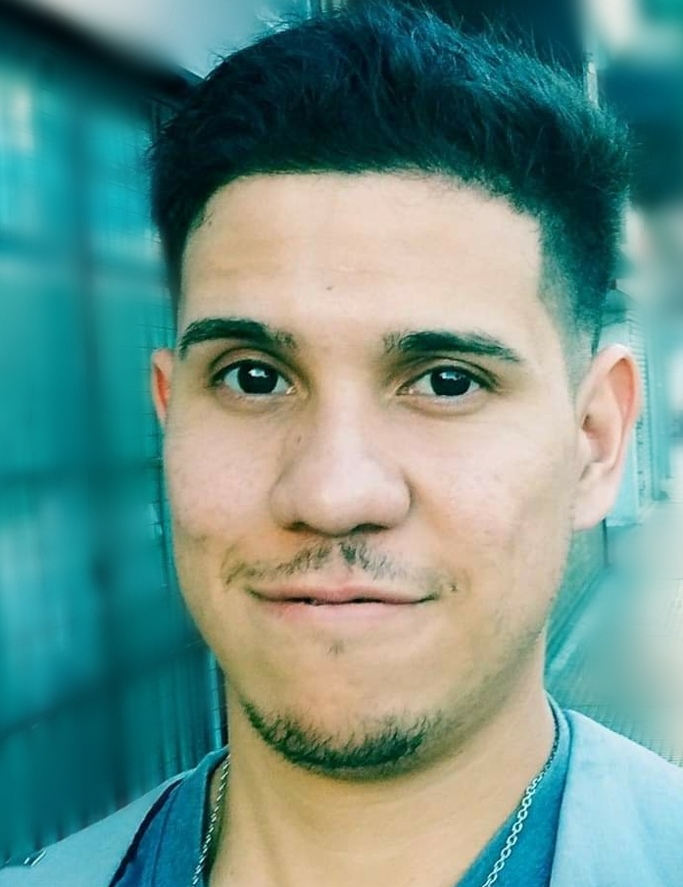

**ABOUT ME**

Im studiyng System Engineering at UTN , i aim to applications development OnPremise and Cloud.

In addition since 2017, I work as a software technician at Garbarino making task realted with support and consultancy.

In my free time i like to learn about last technologies, do some sports and read sci fi books.

**DIPLOMAS Y HOBBIES**

**Formaciones :** Diplomados, Congresos, xxxxxxxxxx xxxxxx xxxxxxxxx xxxxxxxxxxxxxxxxx

**Hobbies:** xxxxxxxxxxxxxxxxxxxxxxxxxxxxxx



**JONATHAN FRANCISCO SEGURA**

**P R O F E S I O N A L E X P E R I E N C E**

**GARBARINO |** TECHNICAL SUPPORT

Tasks:

* Attention and advice to customers related to devices on sale.
* Technical issues resolutions related with SW y HW.
* Technological devices revision and changes approval.
* Knowledge about sales managment system “GENESIS”

06/2017 – Act.

Buenos Aires

**C O N T A C T O**



j.f.segura91@gmail.com



1554641620

San Isidro, Buenos Aires



https://www.linkedin.com/in/jonathan-segura-39109965/

**LANGUAGES**

Inglés : Writing : intermediate

Conversational: intermediate

“i join to virtual meetings in order to improve my skills ”

**E D U C A C I Ó N**

En curso **Information System Engineering**

CABA*UTN- FRBA*

*“Im doing 3ero/4to level subjects”*

2010  **Electronics oriented technician**

BS AS*EET N°3*

* Teamwork
* Commitment
* Resilience
* Proactivity

**S K I L L S**

**IT**

SQL / PLSQL

HTML

CSS

PHP

JavaScript

Git / GitHub

POO

JAVA

WINDOWS

.NET

✓ Lautaro Schein – General Manager at Garbarino S.A. suc Unicenter  
Tel.: 1165144360

**CURSOS**

11/20 **Git y Github profesional**

Bs As*Platzi*11/20 **Object Oriented Programing(OOP)**

Bs As*Platzi*

11/20 **Web Develpoment**

Bs As*Platzi*11/20 **Good practices in writing code**

Bs As*Platzi*

04/21 **JavaScript fundamentals**

Bs As*Platzi*

**PERSONAL REFERENCES**

©AZURIUS